**THE CATHOLIC UNIVERSITY OF EASTERN AFRICA**

**FACULTY OF SCIENCE,**

**DEPARTMENT OF COMPUTER SCIENCE AND INFORMATION SCIENCE**

**STUDENT ATTENDANCE MANAGEMENT SYSTEM**

**BY**

**TONUCCI GIOVANNI**

**1038916**

**A RESEARCH PROJECT SUBMITTED IN PARTIAL FULFILLMENT OF THE REQUIREMENTS FOR THE AWARD OF BACHELOR’S DEGREE IN COMPUTER SCIENCE.**

# DECLARATION

I hereby state that the project work, entitled Student Attendance System, that I am submitting to The Catholic University of Eastern Africa is a project report of the work I completed under the direction of Mr. Ephantus Qarari. This project work is being submitted in part fulfillment of the requirements of the university. This research project's output hasn't been shared with any other institutions.

**STUDENT NAME: TONUCCI GIOVANNI**

Signature: Date:

**Approval**

This project has been submitted for examination with my approval as the university supervisor.

**SUPERVISORS NAME: MR. EPHANTUS QARARI,**

Signature: Date:

# ACKNOLEDGEMENT

My teacher and supervisor, Mr. Ephantus Qarari, has my sincere gratitude for giving me this opportunity to work on my project, and I would like to express my particular appreciation to him. I also want to express my gratitude to my parents for providing me with the environment and support I needed to work on my project without difficulty. Last but not least, I want to express my gratitude to my friend who served as my accounting partner and encouraged me to finish my project on time.

# ABSTRACT

*Global higher education institutions have always stood for honesty when it comes to the handling of student records during storage or transit. With the development of technology, organizations are now looking to automate many processes that happen both during and outside of school hours. The administration of the school has greatly improved thanks to the online management of these activities, which has led to an increase in the number of students eager to enrol at that particular school.*

*Management of inventory, enrolling new students, and even learning have all embraced the escalating technological trends. Simply put, the recent COVID-19 pandemic served as further evidence of how well these systems would function if they were fully automated.*

*The research project aims to maintain and track student attendance records in any higher education institution through the use of a computerized system, which will allow the administration to oversee the process of report generation and staff supervision and will allow the staff to be able to mark attendance directly into the system, giving room to do away with the conventional handwriting method of taking attendance. The system will also offer adequate storage for keeping the records, which will be kept in a database where they can be easily accessed and used to produce reports. All parties will have access to the stored records, including students, who will only be allowed to view them; however, only staff members and administrators will have the ability to modify them.*

# **TABLE OF CONTENTS**

DECLARATION ii

ACKNOLEDGEMENT iii

ABSTRACT iv

TABLE OF CONTENTS v

TABLE OF FIGURES xi

DEFINITION OF KEY TERMS xiii

CHAPTER ONE 14

INTRODUCTION 14

1.1 Motivation and Background 14

1.2 Background of the Research 16

1.3 Problem Statement 17

1.4 Aim of the Research 18

1.5 Objectives 18

1.5.1 Main Objective 18

1.5.2 Specific Objectives 18

1.6 Justification of the Research 18

1.7 Scope of the Research 18

1.8 Research project organisation 19

CHAPTER TWO 20

RESEARCH METHODOLOGY 20

2.1 Chapter Introduction 20

2.2 Methodology of Literature Review 20

2.3 Methodology for Requirement Specification, Data collection and Analysis techniques 20

2.3.1 Requirements Specifications 20

2.3.2 Data collection 21

2.4 Methodology for System Analysis 22

2.5 Data Flow Diagram 23

2.6 Flowchart 24

2.7 Methodology for System Design 25

2.8 Design of the User Interface 26

2.9 Design of the Database 26

2.10 Methodology of System Implementation 26

2.10.1 Software Using/Development Platform 26

2.10.2 Language Using 26

2.10.3 Understanding of Extensible Markup Language 26

2.10.4 IDE System Development Kit Tools 26

2.10.5 Back-End 27

2.10.6 Front-End 27

2.11 Methodology for System Testing plan and Testing Techniques 27

2.11.1 Testing plan 27

2.11.2 Testing technique 27

2.12 Methodology for System Deployment 27

2.13 Chapter Summary 28

CHAPTER THREE: REVIEW OF RELATED WORK 29

3.1 Introduction 29

3.2 History of the Research topic 29

3.3 Review of related prototypes 30

3.3.1 Kissflow HR Cloud 30

3.3.2 GreytHR 30

3.3.3 SumHR 30

3.3.4 Kronos Workforce Management 30

3.4 Emerging trends and patterns 31

3.5 Research gap 31

3.6 Chapter summary 32

CHAPTER FOUR: SYSTEM ANALYSIS 33

4.1 Introduction 33

4.2 Description of the current systems, its strengths and weakness 33

4.3 Feasibility study 34

4.3.1 Technical feasibility 34

4.3.2 Economic feasibility 35

4.3.3 Legal feasibility 37

4.3.4 Operational feasibility 37

4.3.5 Schedule feasibility 37

4.4 Conclusion 38

4.5 Data Input/Output analysis 38

4.5.1 Data Input Analysis 38

4.5.2 Data Output Analysis 39

4.6 Process logic design 40

4.7 Chapter Summary 41

CHAPTER FIVE: SYSTEM DESIGN OF THE PROPOSED SYSTEM 42

5.1 Introduction 42

5.2 Description of the proposed systems, its strengths and weakness 42

5.2.1 Functionalities for the system 43

5.3 Requirements analysis 44

5.3.1 Functional Requirements 44

5.3.2 Non-Functional Requirements 45

5.4 Conceptual architecture of the proposed system 47

5.5 Process logic design 48

5.5.1 Use case Diagram 48

5.5.2 Admin Activity Diagram 49

5.5.3 Student Activity Diagram 51

5.5.4 Staff Activity Diagram 52

5.4 Database Design 53

5.4.1 ER & Normalization 53

5.4.2 Data Dictionary 54

5.5 I/O of the proposed system 57

5.5.1 Home Page 57

5.5.2 Contact Us page 58

5.5.3 View Staff page 58

5.5.4 Feedback page 59

CHAPTER SIX: IMPLEMENTATION SYSTEM 60

6.1 Introduction 60

6.1.1 Implementation of the proposed system 60

6.1.2 System screenshots 60

6.1.3 Home page 60

6.1.4 Login page 61

6.2 Testing plan 61

6.2.1 Phase one 61

6.2.2 Phase two 62

6.2.3 Phase three 62

6.3 Evaluation plan 62

6.3.1 Methodology 62

6.4 Summary 64

CHAPTER SEVEN: CONCLUSIONS, RECOMMENDATIONS & FINDINGS 65

7.1 Introduction 65

7.2 Conclusion 65

7.2.1 Overall 65

7.2.2 Methodology for the requirements specification 65

7.2.3 Methodology for system Analysis 66

7.2.4 Description of the current systems, its strengths and weakness 66

7.2.5 Feasibility study 66

7.3 Challenges Encountered 67

7.4 Future recommendations 69

REFERENCES 70

APPENDIX 72

Research project Schedule 73

Research Project Budget 74

Sample Codes 75

# TABLE OF FIGURES

Figure 1 : Data Flow Diagram 23

Figure 2 Use Case Diagram 40

Figure 3 Conceptual architecture of the proposed system 47

Figure 4 Use case Diagram 48

Figure 5 : Staff Activity Diaram 52

Figure 6 : StudentMst table 54

Figure 7 :StdMst table 54

Figure 8 :StaffMst table 54

Figure 9 :LeaveMst table 55

Figure 10 :FeedBackMst table 55

Figure 11 :DivMst table 55

Figure 12 :Complainmst table 56

Figure 13 :Attendancemst table 56

Figure 14 : Home Page 57

Figure 15 :View Staff page 58

Figure 16 :Feedback page 59

Figure 17 : Admin login page 61

Figure 18 : Gantt Chart 73

Figure 19 : sample codes 75

# DEFINITION OF KEY TERMS

Attendance – refers to the action or state of going regularly to or being present at a place or event.

Registry – a place where records are kept

Online – means to be controlled by or connected to a computer.

Radio Frequency Identification – RFID.

# CHAPTER ONE

# INTRODUCTION

## Motivation and Background

This time period is frequently referred to as an era of technology or technological advancements. In many, if not all, areas of our lives today, technology is extremely important. It is thought to be the cornerstone of economic expansion. It is therefore not surprising that education is one field that has been able to greatly benefit from the development of technology, particularly Information Communication and Technology (ICT). Technology makes the work much easier and less time consuming.

ICT has the potential to improve education's quality and relevance while also increasing access to it. According to Tinio (2002), ICT has a significant impact on education in terms of knowledge acquisition and absorption for both teachers and students through the encouragement of active learning, collaborative and cooperative learning, creative learning, integrative learning, and evaluative learning. Researchers have discovered, according to Gregoire et al., that using ICT typically promotes greater cooperation among students both inside and outside of the classroom, as well as a more interactive relationship between them and their teachers. (Gregorie et al., 1996). In light of the current environment's rapid expansion of knowledge, Jung discusses the enormous challenges that teachers must overcome. The use of contemporary technologies in the classroom is a requirement for teachers. This was particularly clear during the pandemic period, when most educators had to adjust to new cutting-edge teaching methods. Therefore, the need for teacher training is increased by these new technologies. According to Gressard and Lloyd (1985), an important aspect of implementing ICT in education successfully is teachers' attitudes toward computers.

Despite the effects of technology on education, most educational institutions still use the manual method of taking attendance of students, which involves signing along with one's name on a printed class list or just a piece of paper where the student is required to provide their registration number and names and then sign on it. The lecturer must look up each and every student as he or she enters the students' attendance record into the computer before turning it in to the class representative. After the students have signed attendance on the paper, the lecturer must record the date this attendance is being taken before passing the attendance list to the lecturer. Every class has its own unique attendance sheet, which forces the institution to print out a list every week for the various courses offered at the school. This happens on a daily basis. This method shows to be very time-consuming and unreliable. The act of physically handwriting on the paper takes a lot of time, especially when dealing with a large class, and is occasionally ineffective because not all students may have time to sign on the paper within the allotted time despite arriving at class. (Sandra Melo, 2019). There is also the issue of storage space, as paper documents can take up a lot of room as their number grows daily. Because of the difficulty in maintaining records for later use, it is challenging for a student to bring up a concern about their attendance. Any student who stops attending a class without being formally dropped or withdrawn may receive a temporary grade of AB or IN or a permanent grade of FA, according to Education Policy Committee Resolution 2018-1, passed on February 9, 2018. The upkeep and monitoring of student attendance are therefore of utmost importance.

A student attendance system, which provides numerous advantages over the manual method of taking attendance, would be the best way to address these issues. The majority of things in our environment are evolving and becoming more automated, so institutions will need to change and come up with fresh solutions to these problems that have persisted for a century in order to advance significantly. (Christinea Bellana, 2021). Since the system will have multiple layers of security to ensure data security, data insecurity won't be a concern anymore. Accessing data in manual systems was quite a challenge, but in automated systems, the student data is uploaded into a centralized database and only people with the proper authorization can access it. During the grading period, this would be beneficial for both teachers and students. Additionally, it conserves paper because teachers no longer have to carry around multiple attendance records to check how to award points based on a student's attendance. The system is also able to produce reports on demand, weekly, or monthly, and these reports can be used to keep parents updated on their kids' academic progress, including their attendance in class. (Christinea Bellana, 2021)

.

## Background of the Research

One of the most important factors in determining a student's likelihood of success in a higher education setting or other educational setting is attendance. (Broucek, W. G., & Bass, W., 2008). According to Golding (2011), lecturers can use attendance policies like signing a paper, distributing arbitrary in-class writing assignments, and administering weekly quizzes to track who is showing up to class. Attending class allows students to learn more information that may not be covered in their textbooks and is presented by the lecturer. Researchers are debating whether an attendance policy has an impact on a student's performance as a result of this. According to some researchers, students' academic performance and attendance are strongly correlated. (Credé, M.,, Roch, S. G.,, & Kieszczynka, U. M., 2010). Golding (2011) may disagree, but he also insists that it is obvious that having an attendance policy will ensure that students show up for class. The lecturer passing out a piece of paper and asking the students to sign it or having a class list with the students' names already printed and asking them to sign it are the two still most frequently used traditional methods of keeping track of attendance in educational institutions.

Early in the 1960s, one of the first technologies used to take attendance was student response systems, or clickers. (Judson, E. & Sawada, D. , 2002). Clickers are merely a live polling system for classrooms (Lowery, R. C., 2006), but they were also utilized to gather information on attendance (Fies & Marshall, 2006). Another area of technology being used for managing attendance systems is RFID. A RFID tag with some information, a reader to read the information from the tag, and software installed on a computer acting as the host are the three components of an RFID attendance system. (Silva, Filipe, & Pereira, 2008).

The paper-signing method of keeping track of attendance takes a lot of time, especially in a class with lots of students. (Nawaz, Assad, & Khalil, 2010). For the clicker system, the organization had to purchase a system for each class as well as response units for each student. Due to financial restrictions, this works well in smaller institutions but not in large universities. Since the reader can wirelessly and automatically identify them, the RFID attendance system raises privacy and security concerns since the card's owner need not be present to use it.

.

## Problem Statement

One of the most crucial tasks that must be completed, if not daily then frequently, is the recording and upkeep of attendance records in any educational institution. The manual method of recording attendance, which still involves signing a piece of paper, is ineffective and unreliable. The manual system takes a lot of time, especially when working with a class of many students, as passing the paper around for each student to sign takes a lot of time. (Nawaz, Assad, & Khalil, 2010). The manual attendance record takes time to organize records and determine each student's average attendance. It can be a nightmare to sort through the records in order to produce accurate data and statistics, especially when a lecturer is responsible for teaching two or more classes at once from different departments. (Sandra Melo, 2019). Another issue that arises whenever taking attendance on paper is the lack of available storage space. For future reference, and especially if the student or the lecturer needs to go back and consult the data for a specific purpose, these attendance sheets must be stored and kept safe, which is really quiet a tall order to ask of an institution. No matter the size, Sandra (2019) asserts that it is crucial for any organization to safeguard its data and other priceless assets. Paper presents one of the biggest information security risks for businesses because it can be lost, handled carelessly, or damaged, whereas digital data can be encrypted and safely stored in hard drives or other electronic devices. In addition to being easily destroyed by pests, fire, or other natural disasters, manual documents can also easily lose data because there was no backup. Once the data is lost, it is difficult to recover it.

These flaws demonstrate the necessity of creating a system that will automatically arrange the records and figure out each student's average attendance by monitoring them all. The system will also be able to monitor the accuracy and reliability of the reports it generates automatically. To take the place of the manual system, this proposed system is being put forth. The system will address the issue of time consumption because it will be fully responsive and flexible, accessible from any computer or mobile device. Each student will be responsible for keeping track of their own attendance.

.

## Aim of the Research

Save time, keep track of and print a report on each student's attendance, and track and maintain the attendance record of each student.

## Objectives

### Main Objective

Student attendance system.

### Specific Objectives

1. Automate easy report generation for student attendance
2. Provide for easy communication between teacher and student on sensitive matters.

## Justification of the Research

An automatic student attendance system that only needs a computer device connected to the internet is a really good option to pursue given current technological advancements and the world's efforts to go green, which include numerous campaigns to save trees and aim for a paperless society. This system will be web-based, completely responsive, and flexible as a result of the numerous studies and researches done in relation to IoT. The web in particular has grown to be very stable. The student's daily attendance will be able to be recorded without the need for printing any paper, and the attendance report will be automatically generated without taking up any time, making sure there are very few errors or mistakes.

## Scope of the Research

The research aims to be able to create a system that will save time, track, and maintain attendance records among students in a university. For the system administrator, lecturers, and students, respectively, there are three user modules in the student attendance management system project. The system will be empty at first, and the administrator has the authority to create standards and classrooms for the school while also having to add the details of the lecturers. While adding the staff information, the administrator generates unique login credentials for each lecturer. According to the requirements or policies of the institution, all lecturers keep track of students' attendance and produce month-by-month or date-by-date reports. Once logged in, students can view their attendance reports and manage their accounts. To access the system, students are given a special username and password.

## Research project organisation

A research project's organization considers what will be covered in the following chapters; chapter two will focus on the research methodology, which describes how the project will be carried out. The review of other related works is covered in Chapter 3, which compares this research project to others that have been conducted in a manner that is similar. The system analysis of the research project is explained in Chapter 4. The proposed system's system design is examined in chapter five, and the system's implementation and testing are covered in chapter six. The final and concluding chapter, chapter seven, examines the research project's conclusions and suggestions.

# CHAPTER TWO

# RESEARCH METHODOLOGY

## 2.1 Chapter Introduction

This project is developed by using ASP.Net Visual Studio with C# Language and for the database SQL-Server. It is divided into two phases. In the very first phase, feasibility study is conducted, requirement analysis is carried out to understand the need for the system and the necessary modules, such as administrator module, student module, lecturer modules. In the web based module is for the administrator panel to control its all over activates like updating, creation, deletion or any other database changes in the whole project by the administrator and it’s also containing a lecturers registration phase on website where they are registered by the administrator and given a unique username and password to login.

## 2.2 Methodology of Literature Review

There have been several student attendance management systems implemented around the world which have helped schools in maintaining and tracking student attendance records. This helps to provide proof and verification about the system and in this chapter, it reviews existing literature on management information systems.

A literature review is informative and useful start to a particular topic as it identifies what is known in the subject area, areas of conflict or debate and hence help formulate the relevant question for further research. (Bolderston, 2008).

In literature review the major source of information for the research project will be acquired from both online books and hardcopy books from the university's’ library, online articles and blogs, online journals and magazines. There also the possibility of gaining information from interviews, observations and filling out questionnaires which will be performed during the course of the research work.

## 2.3 Methodology for Requirement Specification, Data collection and Analysis techniques

### 2.3.1 Requirements Specifications

Hardware Requirements:

RAM: - 4GB

Hard Disk: - 500GB

Processor: - Intel core i5

Software Requirements

Operating system: Windows 10

Front Design: ASP.Net Visual Studio

Front-end language: C#

Back-end language: SQL

Functional Requirements:

The student attendance checking system will involve functions such as: easily tracking attendance information of student and generating attendance reports quickly.

### 2.3.2 Data collection

Interviews:

According Ryan et al, the use of interviews is majorly common in survey designs and exploratory and descriptive studies. (Ryan et al., 2009). The interview will be of real importance since it will allow a face-to-face meeting with the respondents and they will be able to share their ideas and views or thoughts on how the system works.

Some questions that would be posed to the respondent would be:

* How the students take their attendance?
* How the lecturers mark attendance?
* How attendance records are stored?

Observations:

Observation is a key tool in data collection, and by making observations on how students take attendance, how lecturers keep track of attendance and how the attendance is stored and report is generated, will help not only to collect relevant data but also learn how the system works. Kawulich (2015) states that observation is an exceptional data collection method requiring strong memory and extensive taking of notes.

## 2.4 Methodology for System Analysis

Analysis can be defined as breaking up of a system to find out their nature or function. System analysis and design can be characterized as a set of techniques and processes, a community of interests, a culture and an intellectual orientation. (Manoj Kumar, 2018). The system analysis of the research project will demonstrate how the project will be handling the tasks with the goals and objectives of the research in mind. The process will make use of data flow diagrams (DFD) which will be able to present the flow of data and provide information concerning the inputs and outputs of every single entity and its process.

Flowcharts will also be of interest to demonstrate a graphical diagram to show the sequence of steps followed to solve the problems that the project sought to solve. It will display how the entire phases will be played out and thereby giving a clear understanding of how the system will be relating to other functionalities.

A use case diagram is another tool that will of great importance in representing the interaction of the users with the system. It will also highlight on the relationships between the users and the system and be able to display the actors, system and the goal. The use case diagram will be of great value in identifying and managing the system requirement on how the system performs the tasks it was designed to do by making a set of the possible sequence of interactions between the system and its users.

An Entity-Relationship Diagram (E-R diagram) will be of much help when representing the relationship between the entities in a table. Entities refer to the object of system which generally refers to entity as database table. The E-R diagram will represent the relationship between each table of the database. The E-R diagram represents entity with attributes which is a property of entity. The E-R diagram can either be drawn using the symbols used to draw it or a screenshot of the tables created showing their relationships taken.

## 2.5 Data Flow Diagram

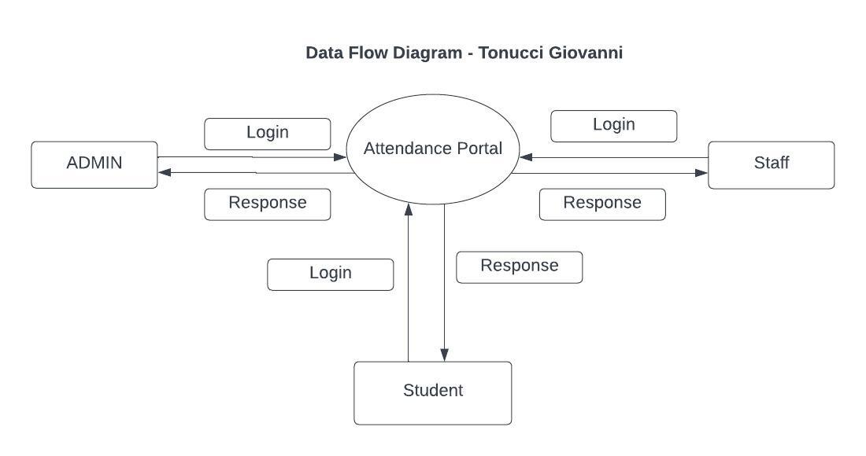

Figure 1: Data Flow Diagram

## 2.6 Flowchart

Figure 2: Admin Flowchart

## 2.7 Methodology for System Design

This will focus on how the system is going to appear, how it interacts and how the database will be represented and the input and output design as well.

**Input Design:**

Input design is part of overall system Design that requires special attention deigning input data is to make the data entered easy and free from errors. The input forms are designed using the controls available in .NET framework.

Input design is the process of converting the user originated inputs to a computer-based format. A system user interacting through a workstation must be able to tell the system whether to accept the input to produce reports. The collection of input data is considered to be the most expensive part of the system design. (Manoj Kumar, 2018). Since the input has to be planned in such a manner so as to get the relevant information, extreme care is taken to obtain right information.

The user Interface (UI) will be user friendly and have at least three windows; home, about us and contact. The home section will require the users to enter their credentials in order to have access to the system. The about us section will provide information about the school and its attendance policies and last but not least the contact section will have communication lines or email addresses to reach out to the institution if the user has a query or an issue.

**Output Design:**

This generally refers to the results and information that are generated by the system for many end-users; output is the main reason for developing the system and the basis on which they evaluate the usefulness of the application. The output is designed in an attractive, convenient and informative way. Forms are designed with various features, which make the console output more pleasing. As the outputs are the most important sources of information to the users, better design should improve the system’s relationships with us and also will help in decision making. Form design elaborates the way output is presented and the layout available for capturing information.

One of the most important factors of the system is the output it produces. This system refers to the results and information generated. Basically, the output from a computer system is used to communicate the result of processing to the user.

Database design will be focusing on the structure of the database and how data will be stored. It will also cover how the interactions with the system will be stored in the database and will be designed using MySQL.

## 2.8 Design of the User Interface

The user Interface (UI) will be user friendly and have at least three windows; home, about us and contact. The home section will require the users to enter their credentials in order to have access to the system. The about us section will provide information about the school and its attendance policies and last but not least the contact section will have communication lines or email addresses to reach out to the institution if the user has a query or an issue.

## 2.9 Design of the Database

In this project we are going to make use of MySQL to create our database. SQL stands for Structured Query Language. MySQL is an open source Relational Database Management System (RDBMS). MySQL is used by many applications like, WordPress. Numerous large scale websites including Google, YouTube, Facebook, Twitter, and Flickr are also using MySQL. On all platforms excluding Windows, MySQL sends with no GUI (Graphical User Interface) to administer MySQL databases or managing the data held within the databases.

## 2.10 Methodology of System Implementation

### 2.10.1 Software Using/Development Platform

Operating system: Windows 10

Front Design: ASP.Net Visual Studio

### 2.10.2 Language Using

MySQL, C#

### 2.10.3 Understanding of Extensible Markup Language

### 2.10.4 IDE System Development Kit Tools

ASP.Net Visual studio

### 2.10.5 Back-End

MySQL

### 2.10.6 Front-End

C#

## 2.11 Methodology for System Testing plan and Testing Techniques

### 2.11.1 Testing plan

Once the source code has been generated, software must be tested to uncover as many errors as possible before the delivery to customer. The goal is to design a series of test cases that have a high likelihood of finding errors. To uncover the errors software techniques are used. These techniques provide systematic guidance for designing test that exercise the internal logic of software components, and exercise the input and output domains of the program to uncover errors in program function, behavior and performance.

### 2.11.2 Testing technique

**Unit testing**

It focuses on verification effort on the smallest unit of software design – the software component or module. The unit test is white-box oriented. The unit testing implemented in every module of student attendance management system, by giving correct manual input to the system, the data stored in database and retrieved. If you want required module to access input or gets the output from the end-user. Any error will find the time will provide handler to show what type of error will have been found.

## 2.12 Methodology for System Deployment

The system will be hosted on a localhost URL on the web browser.

## 2.13 Chapter Summary

From this section on research methodology the research project was able to conduct literature review by referring to books and journals that had previously discussed on student attendance management. Requirement specification allowed the project define what it needs to be able to complete its goals and objectives and also shed light on how data was collected. System design methodology, focused on how the system would look and how the users will be interacting with it. The methodology for system implementation covered the frontend and the backend creation of the system and what tools would be necessary for their creation. System testing was done to look at how we would find out if the system is working correctly and finally the methodology for system deployment sees how the system will go online.

# CHAPTER THREE: REVIEW OF RELATED WORK

## 3.1 Introduction

Reviewing related works will prove to be useful for the purpose of comparisons and analysis on what has been done in the field before and be able to witness if they are efficient and if they are meeting the user’s requirements. The chapter will focus on emerging patterns and trends commonly used in other related works and find gaps that have yet to be solved.

## 3.2 History of the Research topic

Student response systems or clickers were one of the first technologies used to take attendance in early 1960s. (Judson, E. & Sawada, D. , 2002). Clickers are simply a live polling system for classrooms (Lowery, R. C., 2006) but they were also used for collecting attendance data (Fies & Marshall, 2006). Instructors could choose systems that were labelled as either tagged or anonymous. (Littauer, 1972). Tagged systems used to record answers from every seat in the classroom while an anonymous system merely provided a count of the total number of responses to each answer choice. Analyses and printouts on paper of the student responses were possible through the use of computers and typewriters. (Chu, 1927).

As the years moved on and more and more students started being admitted into higher learning institutions the response systems became phased out, but surprisingly with also the advancements in technology higher learning institutions didn’t quite adopt an attendance management system. Although most parts of the education sector were embracing the use of technology to accomplish their tasks and make the tasks look easier, class attendance was still a bit behind. Traditional roll-call pattern was first implemented. This involved the teacher calling the roll and the students replying if they were present, then the teacher grasps the students information in class and marks them out on a paper. No reply would mean the student was absent and not in attendance. After taking the roll the teacher would return with the paper and following it carefully mark out again the student’s attendance on the computer. This proved to be really time consuming.

The paper-signing method of taking attendance proves to be time consuming especially in a class with many students. (Nawaz, Assad, & Khalil, 2010). In the clicker system the organization had to buy a system for each class and also had to order a response unit for each student in the class.

## 3.3 Review of related prototypes

Related works or prototypes help the research project to compare what has been done before and try to come up with a much better system that solves the kinks that were in the previous works in the current project.

### 3.3.1 Kissflow HR Cloud

Kissflow is an optimal attendance management software for an institution. It is a simple smarter system that assists in managing HR-related tasks. The application provides support in attendance management, onboarding, leave management and various other tasks. Key features: real-time information dashboards, analytics, custom reports, optimization and auditing of processes, visual process design. (<https://kissflow.com/hr/>).

### 3.3.2 GreytHR

A cloud-based platform that automates various HR processes. GreytHR assists in disbursing pay slips with one click. The firm offers products for managing payroll, attendance, leaves and employee self-service. They provide real-time integration with attendance recording devices.  Key Features: payroll, leave tracking, real-time attendance, managing employee records, mobile applications for employees. (<https://www.greythr.com/>).

### 3.3.3 SumHR

A school management system that focuses on all HR needs. SumHR is a cost-effective management system that provides reliable support. Makes a big difference in managing the HR tasks in the school using SumHR. The website offers a demo or start trial. Key Features: employee database, biometric device, web attendance, online payroll, GPS clock-in, geo-fencing, onboarding, reports, biometric devices, leave tracking etc. (<https://www.sumhr.com/>).

### 3.3.4 Kronos Workforce Management

Workforce management solutions by Kronos offer solutions regardless of the industry. It is a customer-centric system that helps to drive business outcomes and increase productivity. It is accessible from any device.

Key Features: time & attendance, forecasting & scheduling, absence management, labour activities, analytics, data collection. (<https://www.kronos.in/products/workforce-management>).

## 3.4 Emerging trends and patterns

Emerging trends and patterns defines how the growth of technology is shaping up student attendance management systems and gives just how efficient it is.

RFID is another technological area that has been making recent waves in terms of managing student attendance. RFID is an auto recognition technology that allows RFID reader to read data from RFID tags through wireless communication or radio signals from a distance. (Scanlan, D.A, 2009). RFID attendance system has three parts which are: a RFID tag that has some information, a reader to read the tag information and a software installed on a computer as host to analyse the data. (Silva, Filipe, & Pereira, 2008). Nowadays, many higher learning institutions have implemented an attendance management system that takes care of student attendance using RFID technology, which has aided in saving time for both the lecturer and student hence phasing out the need to take attendance manually.

The use of student biometric details e.g., fingerprint is also another way of taking attendance that has been catching on rapidly. According to MasterSoft the biometric attendance system enables institutions to maintain security by tracking students’ attendance with high degree of precision.

## 3.5 Research gap

The research project has so far not been able to solve how to physically know if the student has attended class since it will be accessible from anywhere as long as there is internet connectivity. The project will therefore still be requiring the lecturer to physically identify the students present in class and from that point use the system to mark them as either absent or present. The proposed system majorly just focuses on record management, report generation and giving students an interface to communicate with their lecturers directly and monitor their progress in terms of attendance. The project will not be able to capture student biometric information or use the RFID technology to check in students.

## 3.6 Chapter summary

This chapter dived into related systems available in the industry that have been in use helping manage attendance in institutions. The existing systems were designed to complete their specified goals and objectives and also satisfy user requirements. The related systems provided a benchmark showing how their structures are and the processes followed to take attendance of students in learning institutions.

The emerging trends and patterns provided a deeper insight in how student attendance management is shaping up with the current growth in technology. The use of biometrics and RFID technology to mark student attendance were some of the examples.

# CHAPTER FOUR: SYSTEM ANALYSIS

## 4.1 Introduction

This chapter will cover the system analysis and how the process logic designs of the current system are used with flowcharts, context diagrams, and data flow diagrams. The description of the current system will also be discussed in the meantime. According to Ifeanyi Cosmas (2018), system analysis is an exciting endeavour as well as an active field in which analysts continually learn new techniques and approaches to develop systems more effectively and efficiently.

Many feasibility studies will be performed by the researcher. Mukherjee and Roy (2017) claim that the feasibility analysis is a method to foretell the results of a test or evaluation of a proposed scheme, as well as any potential benefits. It allows proper investigation and evaluation of the development of a project prospect and also on the necessary requirement to commence the project. To determine the system's goals, the researcher will investigate the system and all of its constituent parts. The problem-solving methods that will increase the system's effectiveness in operation are system analysis.

## 4.2 Description of the current systems, its strengths and weakness

The current system is manual and all its functionalities are done manually. To take class attendance in a class a signing attendance sheet with the students’ name and admission number is passed around and the student signs adjacent to their name in the blank spaces provided. After the lecture has ended the teacher would have again to go through each students’ name on the list and look at who was present or absent and then input the records on their computers before submitting it to the administration.

The administrator is able to add a member of staff in the system by writing the details of the staff in their staff registration book. When a new member of staff joins the administrator captures his/her details like their ID number, name, age, address and the unit they will be teaching. All these details will be stored in the record book to help the admin manage the system. The administrator is responsible for collecting the attendance registers from lecturers, collating the data, and storing it for future reference. They are also responsible for generating reports on attendance data.

The lecturer is responsible for marking student attendance during each class and ensuring the accuracy of the data recorded. They may also be required to follow up with absent students to determine the reason for their absence.

The student is responsible for attending each class and ensuring their name is marked on the attendance register. They may also be required to provide a valid reason for any absences, particularly if attendance is a requirement for passing the course.

The manual attendance system using the paper method is relatively simple and easy to use, requiring minimal technical skills or training and it is cost-effective as it does not require any expensive technology or equipment. The system allows for a physical record of attendance that can be easily accessed and reviewed if needed. Moreover, it is less susceptible to technological failures or data breaches. This system has been in place for a very long period of time and though its has proved every bit reliable, the system is time-consuming and can be prone to errors, particularly if the handwriting is illegible or if there are missing or duplicated entries and the system is not as efficient as automated methods, particularly for larger classes where attendance taking can take a significant amount of time. The system is also not easily scalable and may not be suitable for larger schools or universities with multiple courses and classes. The system relies heavily on human factors, including the reliability and accuracy of the lecturer and administrator.

## 4.3 Feasibility study

The following feasibility studies were conducted as a result of a feasibility study:

### 4.3.1 Technical feasibility

After conducting research on the available and current technology, it was discovered that all the necessary resources and skills are available for developing the system, including those for problem-solving, security awareness, and programming. This combination of hardware and software can support the system to be well implemented or built. There are sufficient tools (ASP.NET(C#), for example) for programming languages that can be used to put the system into practice. These programming languages are frequently open-source, which means that anyone can use them.

Laptops and desktop computers will be helpful in terms of the technical aspect of the hardware, it was discovered. These devices are available tools for implementing the system.

Regarding the technical knowledge and prowess required to put the system into place. The research developer is familiar with ASP.NET(C#), which will be utilized to implement the system. Following technical feasibility research, it was determined that the system software is technically feasible.

### 4.3.2 Economic feasibility

The management will gain from streamlining the data processing and production processes, which will result in higher levels of quality control and lower production costs. The system will benefit users by facilitating operations and accelerating information access, both of which would not be possible without system implications.

The goal of the research project is to reduce spending at the educational facility. As a result of the system's implications, once it is put into use for managing student attendance, 64% of the budget will be saved. See the illustration below.

|  |  |  |  |  |
| --- | --- | --- | --- | --- |
| **Current Assets** | | | | |
| # | **Name** | **Unit price in KSH** | **Quantity** | **Total price in KSH** |
| **1.** | Box of Pens | 500 | 1 | 500 |
| **2.** | Ream of printing paper | 1000 | 1 | 1000 |
| **3.** | Credit for phone calls | 100 | 30 | 3000 |
| **4.** | A4 envelopes | 250 | 2 | 500 |
| **5.** | Rubber stamp ink | 500 | 2 | 1000 |
| **6.** | Note book | 1000 | 1 | 1000 |
| **7.** | Salary team | 50000 | 4 | 150000 |
| **8.** | Maintenance | 6000 | 1 | 6000 |
| **9** | Internet | 3000 | 1 | 3000 |
| **10.** | Miscellaneous | 30000 | 1 | 30000 |
|  |  |  |  |  |
|  | **Total** | **196000** |  | **2352000** |
|  |  |  |  |  |

Table 1With implications of the software system

|  |  |  |  |  |
| --- | --- | --- | --- | --- |
| **Current Assets** | | | | |
| **#** | **Name** | **Unit price in KSH** | **Quantity** | **Total price in KSH** |
| **1.** | Books | 500 | 10 | 5000 |
| **2.** | Box of pens | 500 | 1 | 500 |
| **3.** | Box of papers | 3000 | 3 | 9000 |
| **4.** | File storage boxes | 1500 | 4 | 6000 |
| **5.** | Credit for phone calls | 300 | 30 | 9000 |
| **6.** | A4 envelopes | 300 | 2 | 600 |
| **7.** | Rubber stamp ink | 500 | 5 | 2500 |
| **8.** | 3X3 Sticky Notes | 1200 | 1 | 1200 |
| **9.** | Note book | 1000 | 3 | 3000 |
| **10.** | Box of pencils | 500 | 1 | 500 |
| **11.** | Box of erasers | 200 | 1 | 200 |
| **12** | Staple pins | 500 | 5 | 2500 |
| **13.** | Salary team | 40000 | 10 | 400000 |
| **14.** | Miscellaneous | 100000 | 1 | 100000 |
|  |  |  |  |  |
|  | **Total** |  | **540000** | **6480000** |

Table 2Without the implication of the software system

*Cost benefit analysis of the software system*

|  |  |  |  |  |
| --- | --- | --- | --- | --- |
| Cost Benefit Analysis | | | | |
| **Category** | **Name** | **Unit price in KSH** | **Quantity** | **Total price in KSH** |
| **Hardware & Services** | User workstation | 30000 | 2 | 60000 |
|  | Server system | 10000 | 1 | 10000 |
|  | Printer |  | 1 | 20000 |
|  | Software licenses |  | 1 | 50000 |
|  | Cable installation |  | 1 | 400 |
| **System training** | System overview |  | 2 | 10000 |
|  | Miscellaneous |  | 1 | 5000 |
|  |  |  | **Total costs** | **159000** |
| Benefits | | | | |
| # | **Name** | | | **KSH** |
| **1.** | A more efficient system. | | | 900000 |
| **2.** | Improved systemic communication. | | | 400000 |
| **3.** | Process effectiveness. | | | 800000 |
| **4.** | Making a swift and safe decision. | | | 900000 |
|  |  | | |  |
|  | **Total benefits** | | | **4128000** |

Table 3Cost benefit analysis of the software system

**Summary**

The system's implications mean that the school will spend 2352000 and save 4128000 each year, or 64%.

2352000 / 6480000 X 100 = 36%

4128000 / 6480000 X 100 = 64%

The system will be economically viable, according to the results of the economic feasibility study. As a result of the budget being reduced by 64 percent annually.

### 4.3.3 Legal feasibility

The research project does not contravene with any existing law in the Kenyan constitution. The system is in line with the Kenya Communications Act (No. 2 of 1998) and as amended by the Kenya Communications (Amendment) Act, 2009, and the Kenya Information and Communications (Amendment Act) 2013 which provide the main framework for regulating the communications sector in Kenya. The system also obeys Act No. 5 of 2018 against computer misuse and cybercrimes.

Based on the legal feasibility carried out, it was identified that the system will be legally viable.

### 4.3.4 Operational feasibility

The research project will take care of any additional tasks that may be needed once the system is operational. There won't be any disruption to the institutions' culture or religion as a result of the research project.

The system will be operationally viable, according to this operational feasibility carried out.

### 4.3.5 Schedule feasibility

According to the system requirements, the timelines of two semesters and eight months will be practical for delivering a finished and operational research project system on schedule. The proposed system satisfies the requirements for the project's start and completion on schedule given the availability of the existing requirements.

If the system is viable according to this schedule, it will be.

## 4.4 Conclusion

The system's technical, financial, legal, operational, and schedule viability has been amply demonstrated based on the feasibility studies that have been conducted. According to research on feasibility, the system can be implemented successfully.

## 4.5 Data Input/Output analysis

This section will outline the types of data that are stored, processed, and displayed by the system, as well as how those data relate to one another. The analysis of data input and output for the current system is as follows.

### 4.5.1 Data Input Analysis

A manual paper method student management attendance system typically involves the use of a physical attendance register, where lecturers mark student attendance by hand. The register contains columns for course name, date, and a list of student names. The lecturer then checks off the names of students present on the day. The register is then collected by an administrator who collates the data and stores it for future reference.

Data input analysis of this system includes the following:

1. Course Name: The course name is a required input field in the attendance register. It helps to identify the particular course for which the attendance is being taken. The course name should be accurate and clearly stated to avoid any mix-up of data.
2. Date: The date is another required input field in the attendance register. It helps to identify the specific date for which the attendance is being taken. The date should be accurate to avoid any confusion, especially when reviewing attendance data later.
3. Student Names: The attendance register should contain a list of all the students enrolled in the course. The student names should be accurately spelled and updated to ensure that the attendance data is correct.
4. Attendance Status: The attendance register should have a section where the lecturer can mark the attendance status of each student. This could include "present," "absent," "late," or "excused absence." The attendance status should be accurately marked to ensure that the attendance data is correct.
5. Signature: The lecturer should sign the attendance register after marking the attendance status of each student. The signature verifies that the attendance data is accurate and was taken by the lecturer.
6. Recording of Attendance Data: The attendance data should be recorded accurately in the attendance register. This includes ensuring that there are no missing or duplicated entries, and that the handwriting is legible. The administrator responsible for collating the data should also ensure that the data is accurate and stored in a secure location.

In conclusion, the manual paper method student management attendance system requires accurate data input to ensure that the attendance data is reliable and useful. The input fields should be clearly defined, and the data should be accurately recorded and securely stored for future reference.

### 4.5.2 Data Output Analysis

Data output analysis of this system includes the following:

1. Attendance Data Reports: The attendance data reports are usually generated by the administrator responsible for collating the data. The reports provide an overview of the attendance data for a specific course, including the number of classes held, the number of students present, absent, and late. The reports may also include individual student attendance records for the course.
2. Analysis of Attendance Data: The attendance data can be used to analyze student attendance patterns and identify areas where improvements can be made. For example, if a student has a high number of absences, the lecturer can follow up with them to determine the reason for their absence and provide support if needed.
3. Attendance Records: The attendance register serves as a physical record of attendance that can be easily accessed and reviewed if needed. The attendance records can be used to verify student attendance for a specific class or course and can be used as evidence in cases where attendance is required for passing the course.
4. Feedback to Students: The attendance data can be used to provide feedback to students on their attendance and punctuality. The lecturer can use the attendance data to provide positive feedback to students who have good attendance records and provide support and guidance to those with poor attendance records.
5. Compliance with School Policy: The attendance data can be used to ensure compliance with school policies on attendance. For example, if attendance is required for passing the course, the attendance data can be used to determine if a student has met the attendance requirements.

In conclusion, the manual paper method student management attendance system provides a range of data outputs that can be used to analyze student attendance patterns, provide feedback to students, and ensure compliance with school policies. The attendance data reports, attendance records, and analysis of attendance data are all essential outputs that can be used to improve student attendance and ensure academic success.

## 4.6 Process logic design

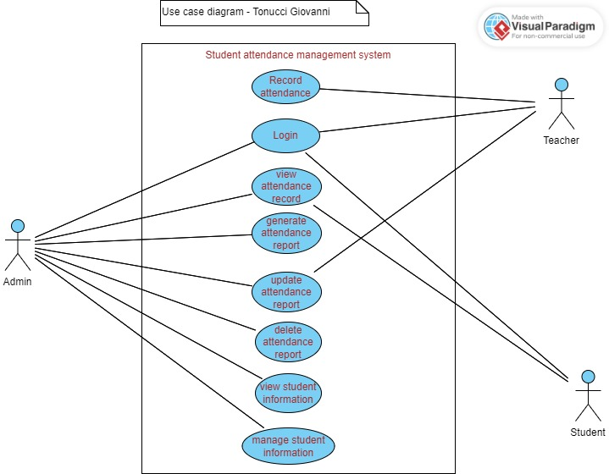The figure below is the use case for the student attendance management system.

Figure 2 Use Case Diagram

## 4.7 Chapter Summary

In this chapter, the existing systems in higher education institutions are described in detail along with how effectively they operate. The requirements analysis focused on the users' expectations for the proposed system and what they actually wanted, while the feasibility study demonstrated the system's viability and demonstrated that it could be implemented without any issues. The UML's process logic is shown in order to create a sound system.

# CHAPTER FIVE: SYSTEM DESIGN OF THE PROPOSED SYSTEM

## 5.1 Introduction

This chapter will discuss the proposed system's system design, including how requirement analysis, conceptual architecture, process logic design, database design, and input/output of the proposed system will function to accomplish the goal.

In order to determine the goals that the system will need to achieve, the system design will study its constituent parts. According to (Singh, S & Kotzé, P, 2003), the user interface serves as the foundation for the design of the system. Between 37 and 50 percent of efforts made during the software life cycle are focused on the user interface of the system.

## 5.2 Description of the proposed systems, its strengths and weakness

The proposed system is meant to manage student attendance which allows educational institutions to record and manage attendance data of students online. It is an efficient and effective way of keeping track of student attendance, which is important for monitoring student progress, identifying attendance issues, and ensuring compliance with school policies. The system typically includes the following features:

Student profiles: This feature allows schools to store and manage student information, such as names, classes, and other relevant details.

Attendance tracking: This feature enables schools to keep track of student attendance, whether it is in-person or online. Teachers can mark students present or absent and view attendance reports for individual students or entire classes.

Notifications: This feature alerts teachers and administrators of absences or tardiness, making it easier to follow up with students and parents.

Reports and analytics: This feature generates detailed reports and analytics, allowing schools to identify trends in attendance patterns, such as students who are frequently absent or tardy.

The system's benefits in use include some of the following:

1. Time-saving: The system eliminates the need for manual attendance tracking, saving teachers and administrators valuable time that can be spent on other important tasks.
2. Improved accuracy: The system ensures accurate attendance records, reducing errors that can occur with manual tracking.
3. Real-time monitoring: The system provides real-time monitoring of attendance, making it easier for teachers and administrators to respond to attendance issues promptly.
4. Data analysis: The system provides valuable data analysis, allowing schools to identify trends in attendance patterns and implement targeted interventions to improve attendance.
5. Increased communication: The system provides a platform for increased communication between teachers, administrators, students, and parents, allowing for greater collaboration and support.

The system's weaknesses in use include some of the following.:

1. Technical issues: The system relies on technology, which can be prone to technical issues that can affect its performance.
2. Security concerns: The system stores sensitive student information, making it important to ensure that it is secure and protected from unauthorized access.
3. Limited access: The system requires internet access, which can limit its accessibility in areas with limited connectivity.
4. Cost: The system can be costly to implement and maintain, requiring ongoing investment in hardware, software, and training.
5. Resistance to change: Teachers and administrators may be resistant to change, making it important to provide adequate training and support to ensure that the system is adopted successfully.

### 5.2.1 Functionalities for the system

**Admin:** In this project, the owner or director of the school has admin rights. The Admin is the person who runs and manages the system. A system's framework for creating standards and classrooms is developed by the administration.

**Admin Functionalities**:

Add Standard, Add Division / Classroom, Add Staff, Manage Complain, Leave Reports, Manage Reports

**Staff :** The main aim of the attendance system fulfill by staff. Staff can add student detail and fill the attendance daily for his division. The staff can only fill attendance for his division students and he can manage leaves and complains made by only his division student.

**Staff Functionalities :**

Add Student, Fill Attendance, Manage Leave, Manage Complain, Manage Reports, Change Password

**Student :**All student have unique username and password to access the system. After login into system student can view his attendance reports and manage his account. If any student has any problem regarding education, he can directly make complain to his class teacher using this system. Student can apply for leave through the system and he can get reply from his class teacher about his leave status.

**Student Functionality :**

Manage Account**,** Make Complain**,** Apply for Leave**,** Attendance Reports**,** Change Password

## 5.3 Requirements analysis

Functional, non-functional, and user requirements for the system will all be analyzed as part of the research analysis, which will also look at the system's usability.

### 5.3.1 Functional Requirements

The functional requirements of an online student attendance management system include the following:

1. User registration: The system will allow students and teachers to create their accounts and log in to the system using their login credentials.
2. Attendance tracking: The system will allow teachers to mark attendance for students either manually or automatically.
3. Attendance report generation: The system will generate attendance reports for students that can be accessed by teachers and administrators.
4. Notification system: The system will have a notification system that alerts students and teachers of attendance-related events such as when a student is absent or when attendance is updated.
5. Dashboard: The system will have a dashboard that provides an overview of the attendance status of students in a class.
6. Access control: The system will have access controls that restrict access to attendance information to authorized users only.
7. Integration with other systems: The system will be able to integrate with other systems such as student information systems and learning management systems to import and export attendance data.
8. Mobile accessibility: The system will be accessible on mobile devices to allow teachers and students to mark attendance or view attendance reports remotely.
9. Data management: The system will be able to store and manage attendance data securely and accurately.
10. Customization: The system will allow administrators to customize attendance rules, such as the marking of tardiness, to suit their institution's specific needs.

### 5.3.2 Non-Functional Requirements

Non-functional requirements for an online student attendance management system include:

1. Security: The system will have robust security measures in place to protect sensitive student data from unauthorized access and cyberattacks.
2. Scalability: The system will be able to handle a large number of students and faculty members, as well as a high volume of attendance data.
3. Performance: The system will be fast and responsive, with minimal downtime, to ensure that attendance data can be recorded and accessed in real-time.
4. Reliability: The system will be dependable and consistent, with accurate attendance records that can be relied upon for reporting and decision-making.
5. Accessibility: The system will be accessible to all students, faculty members, and administrators, regardless of their location or device.
6. Usability: The system will be easy to use and navigate, with a user-friendly interface that requires minimal training for users.
7. Compliance: The system will comply with relevant legal and regulatory requirements, such as data protection and privacy laws.
8. Integration: The system will be able to integrate with other systems, such as learning management systems or student information systems, to streamline processes and reduce duplication of effort.
9. Customization: The system will allow for customization to meet the unique needs of the institution, such as the ability to configure attendance rules and thresholds.
10. Reporting: The system will have robust reporting capabilities, allowing administrators to generate attendance reports for individual students, classes, or departments.Top of Form

## 5.4 Conceptual architecture of the proposed system

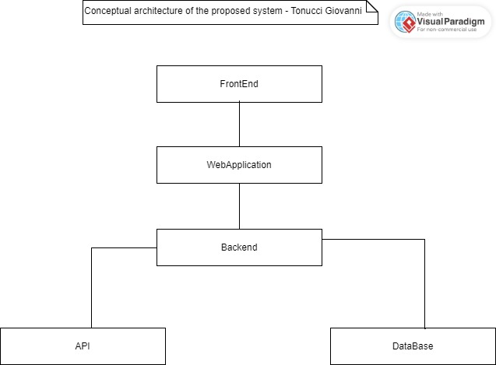Figure 3 Conceptual architecture of the proposed system

## 5.5 Process logic design

### 5.5.1 Use case Diagram

### 

Figure 4 Use case Diagram

### 5.5.2 Admin Activity Diagram

Figure 6: Admin Activity Diagram

### 5.5.3 Student Activity Diagram

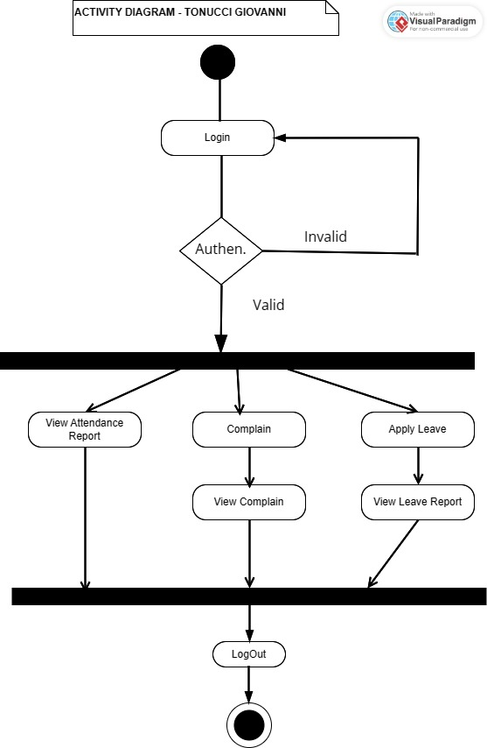

Figure 7: Student Activity Diagram

### 5.5.4 Staff Activity Diagram

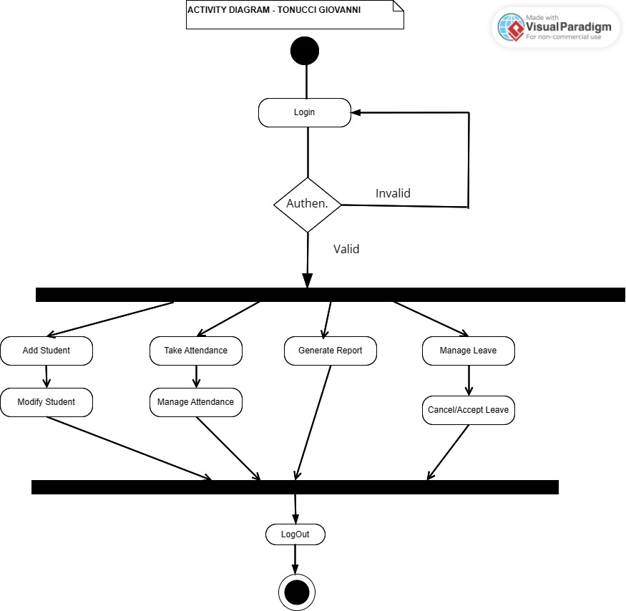

Figure 5: Staff Activity Diagram

## 5.4 Database Design

### 5.4.1 ER & Normalization

Figure 9: ER Diagram

### 5.4.2 Data Dictionary

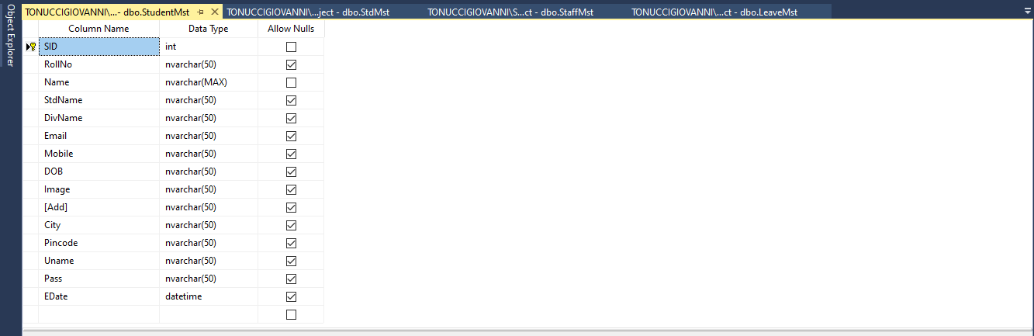

Figure 6: StudentMst table

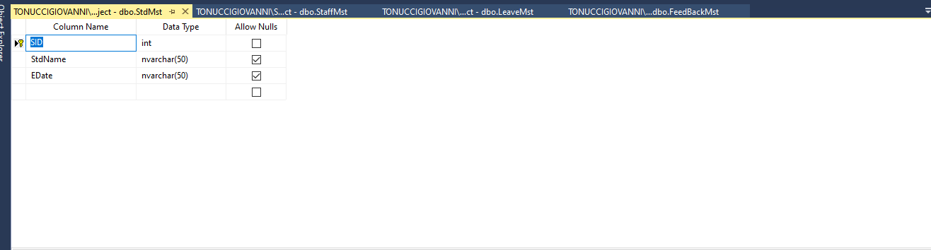

Figure 7:StdMst table

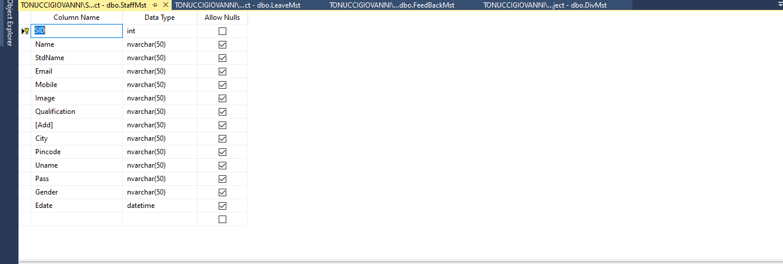

Figure 8:StaffMst table

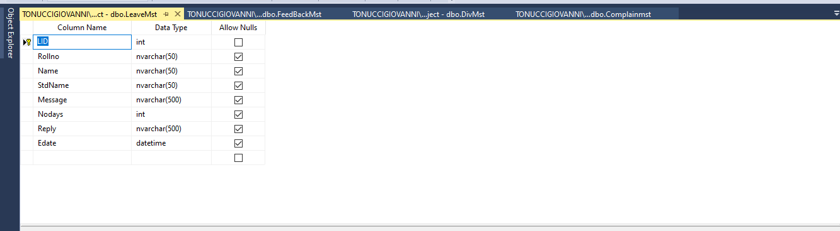

Figure 9:LeaveMst table

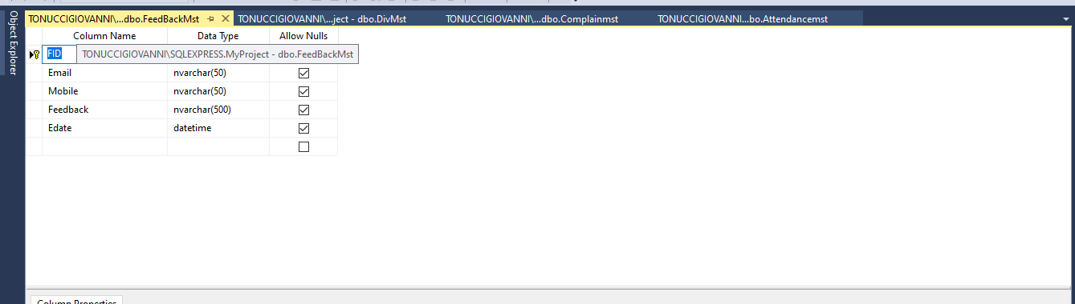

Figure 10:FeedBackMst table

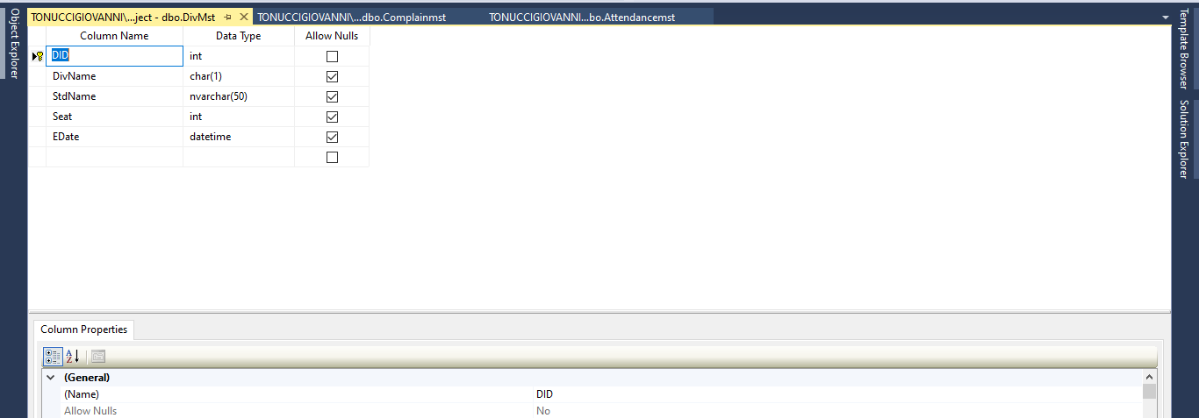

Figure 11:DivMst table

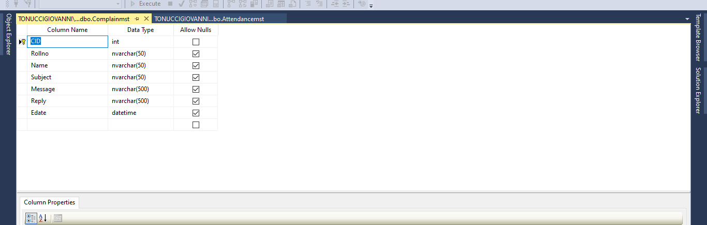

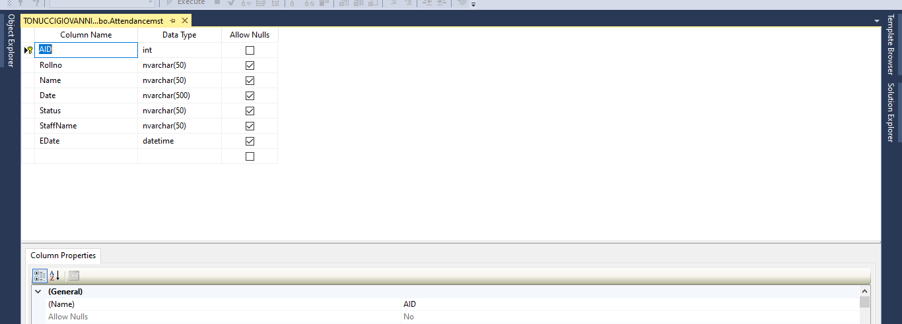Figure 12:Complainmst table

Figure 13:Attendancemst table

## 5.5 I/O of the proposed system

### 5.5.1 Home Page

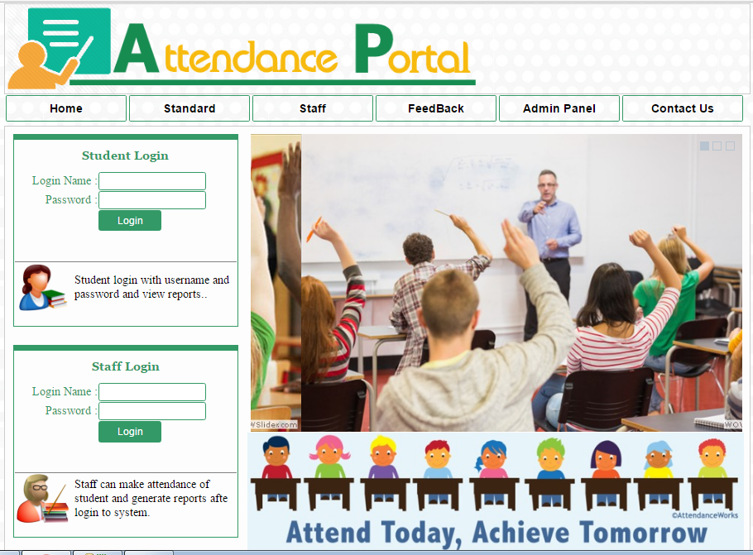

Figure 14: Home Page

### 5.5.2 Contact Us page

Figure 19: Contact Us page

### 5.5.3 View Staff page

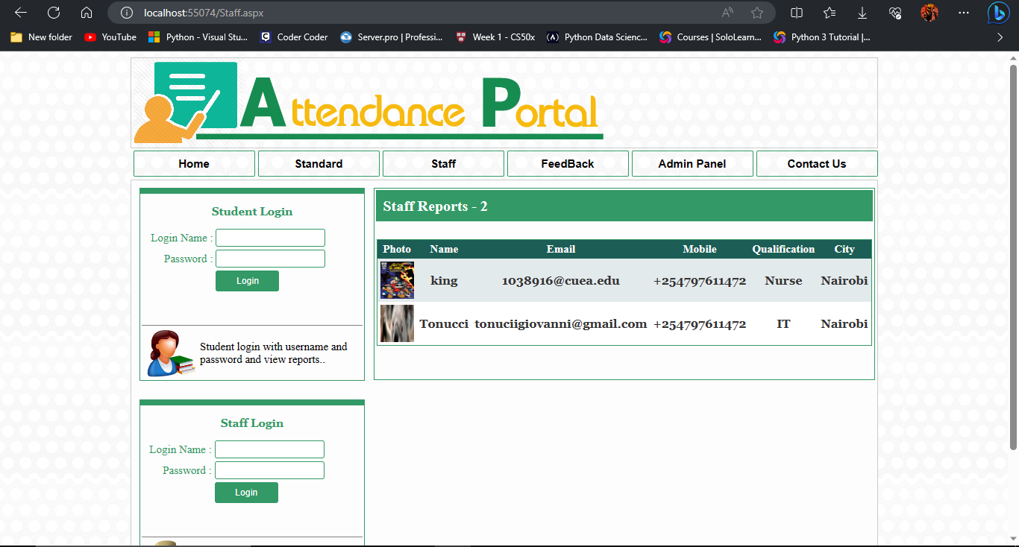

Figure 15:View Staff page

### 5.5.4 Feedback page

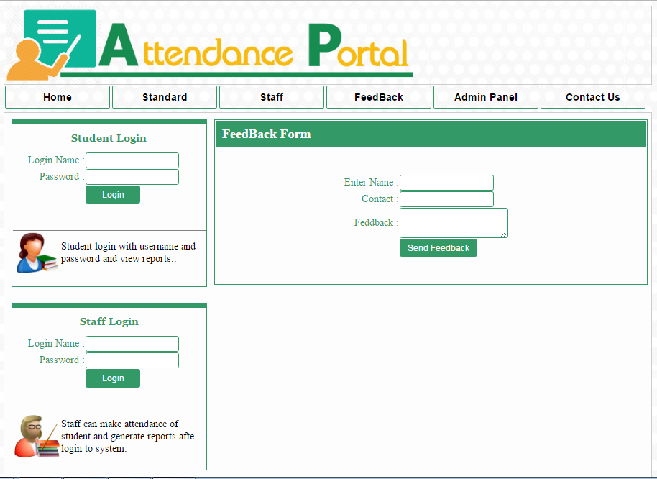

Figure 16:Feedback page

# CHAPTER SIX: IMPLEMENTATION SYSTEM

## 6.1 Introduction

This chapter will talk about the implementation and the testing of the proposed system; and it

will be describing the features that the proposed system was using in order to come up with a

fully functional computerized system.

### 6.1.1 Implementation of the proposed system

The proposed system is made to be accessible across all platforms in order to allow all users to

access the system anywhere at any time. The implementation was well discussed in chapter two

and chapter four hence it captured everything.

### 6.1.2 System screenshots

The proposed system has many functional requirements to be executed in the system, few

screenshots will be shared in order to show how the system looks and how other functional

requirements look.

### 6.1.3 Home page

The home page of the proposed system will help the users to navigate within the system and be able to access pages such as login, contact us and Feedback.

Below is the screenshot of the landing page.

Figure 22:The home page

### 6.1.4 Login page

The system will be having a admin login section which will allow administrators to access the system by providing their validated credentials.

Below is the screenshot of the login page

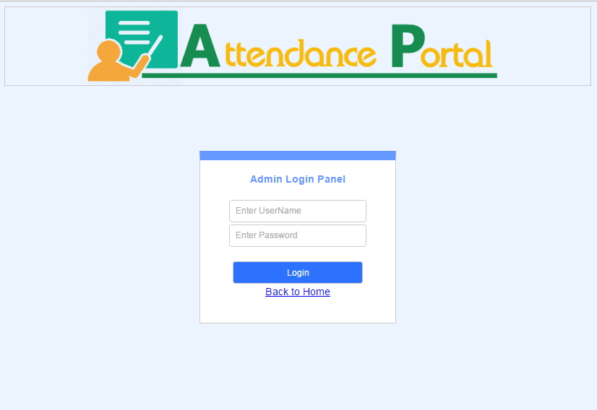

Figure 17: Admin login page

## 6.2 Testing plan

The proposed system was tested once the implementation was done. A group of people were identified for pilot testing. The proposed system plan was done into three phases as discussed below:

### 6.2.1 Phase one

The group of people identified launched the system and started testing by writing down how the system was working while mentioning bugs and insufficient features found in the system. The bugs found in the system were submitted through the developer’s email address and the system was shut down for a while to fix all bugs and implement insufficient features were found accordingly.

### 6.2.2 Phase two

The proposed system was accessible again to the group of the identified people for the second test after the implementation for phase one was done completely. Feedbacks were almost positive compared to the phase one testing. Again, the system was shut down for the relevant implementation.

### 6.2.3 Phase three

The proposed system was again accessible to the group of the identified people for another testing to check whether all feedbacks were completely well implemented. Happily, at the stage three all were smoothing well, all feedbacks were positive at 100%.

## 6.3 Evaluation plan

This section will be very important because it will carry the feedback either positive or negative from a certain group of people who will be identified therefore the feedback that will be carried out will lead the research project work for future recommendations. The proposed system will be evaluated to check if all the functional requirements were fully well implemented.

### 6.3.1 Methodology

**Functional Requirements**

The functional requirements of an online student attendance management system include the following:

User registration: The system will allow students and teachers to create their accounts and log in to the system using their login credentials.

Attendance tracking: The system will allow teachers to mark attendance for students either manually or automatically.

Attendance report generation: The system will generate attendance reports for students that can be accessed by teachers and administrators.

Notification system: The system will have a notification system that alerts students and teachers of attendance-related events such as when a student is absent or when attendance is updated.

Dashboard: The system will have a dashboard that provides an overview of the attendance status of students in a class.

Access control: The system will have access controls that restrict access to attendance information to authorized users only.

Integration with other systems: The system will be able to integrate with other systems such as student information systems and learning management systems to import and export attendance data.

Mobile accessibility: The system will be accessible on mobile devices to allow teachers and students to mark attendance or view attendance reports remotely.

Data management: The system will be able to store and manage attendance data securely and accurately.

Customization: The system will allow administrators to customize attendance rules, such as the marking of tardiness, to suit their institution's specific needs.

**Non-Functional Requirements**

Non-functional requirements for an online student attendance management system include:

Security: The system will have robust security measures in place to protect sensitive student data from unauthorized access and cyberattacks.

Scalability: The system will be able to handle a large number of students and faculty members, as well as a high volume of attendance data.

Performance: The system will be fast and responsive, with minimal downtime, to ensure that attendance data can be recorded and accessed in real-time.

Reliability: The system will be dependable and consistent, with accurate attendance records that can be relied upon for reporting and decision-making.

Accessibility: The system will be accessible to all students, faculty members, and administrators, regardless of their location or device.

Usability: The system will be easy to use and navigate, with a user-friendly interface that requires minimal training for users.

Compliance: The system will comply with relevant legal and regulatory requirements, such as data protection and privacy laws.

Integration: The system will be able to integrate with other systems, such as learning management systems or student information systems, to streamline processes and reduce duplication of effort.

Customization: The system will allow for customization to meet the unique needs of the institution, such as the ability to configure attendance rules and thresholds.

Reporting: The system will have robust reporting capabilities, allowing administrators to generate attendance reports for individual students, classes, or departments.Top of Form

## 6.4 Summary

This section is all about the implementation of the system and the testing as well. The evaluation

of the proposed system and how it was intended to be done.

# CHAPTER SEVEN: CONCLUSIONS, RECOMMENDATIONS & FINDINGS

## 7.1 Introduction

This chapter will talk about the conclusion of the entire research project work, findings and the recommendations of the proposed system. The proposed system aims at developing computerized system software for managing a prison institution.

## 7.2 Conclusion

### 7.2.1 Overall

The current technology has driven and played a vital role in people’s daily lives therefore companies have been benefiting positively the greatness of it. The prison management will benefit the use of the technology by integrating the ways of managing the institution by making quick decision, protecting data integrity, confidentiality and making the system available at any time given.

### 7.2.2 Methodology for the requirements specification

We were been able to learn about the methodology for requirement specification on how to collect data using a variety of techniques such as:

#### 7.2.2.1 Observation

In this section we were able to learn how to pay more attention on every activity that is done in

the learning institution especially when it comes to admit generating attendance reports.

#### 7.2.2.2 Questionnaires and surveys

We were able to learn how to prepare questions and to approach the participants by guiding them while giving us the feedback regarding the questions in the printed forms.

#### 7.2.2.3 Interviews

We were able to learn how to approach and interviewee and learn from their feedback that were given while we were conducting the interview session.

### 7.2.3 Methodology for system Analysis

We were able to learn how to conduct the system analysis by distinguishing the differences between the DFDs and the flowcharts and other process logic.

### 7.2.4 Description of the current systems, its strengths and weakness

We were able to learn about some current organizations’ structures, the relationships among

them and how are the performances of their functionalities in the current system. We were been

able to see and to learn how to capture the details of a new staff who is being adedd to the

institution, we were been able to see and to learn how to capture the details for a new student who is being registered to the current system, and how the reports are being captured when they are

needed.

#### 7.2.4.1 Weaknesses strengths for the current systems

In this section we were been able to compare the weaknesses and the strengths for the current

systems in different aspects. The current systems cannot be able to handle the processes of

producing all the reports as it might be required due to lack of the automated systems, every

single task in the current system is written down which can cost very high the management in

case one book get lost. Regarding that we were also able to learn and to compare the strength of

the current systems as well. The current systems build strong relationships among the

organizations and it doesn’t interfere with the use of the technology in terms of reducing the cost

in the monthly expenditures.

### 7.2.5 Feasibility study

We were been able to learn about the feasibility study on many aspects.

#### 7.2.5.1 Technical feasibility

In technical feasibility we were able to learn that with the availability of the hardware and the

software. The system can be well implemented and in terms of software section the system is

supported by all programming languages that are across the world such as JavaScript, PHP, C# and more others.

#### 7.2.5.2 Economic feasibility

We were able to learn and to compare the cost benefits between the current systems and the proposed system in terms of how much money are spent on both sides. In addition we learnt how the proposed system is very effective in cutting off the expenditures.

#### 7.2.5.3 Legal feasibility

We were able to learn about the law and regulations that a system must follow in order to comply with government’s rules and regulations. We were taught to respect the data privacy, integrity and confidentiality of users of the system in an organization.

#### 7.2.5.4 Operational Feasibility

We were able to learn how the system can handle the over workload within the system accordingly and there will be no disruption regarding the users while interacting with the system and we learnt how the system can be supportive in case of extra functions are required later in future.

#### 7.2.5.5 Data Input /Output analysis

We were able to lean how data in the system is being captured and displayed according to the users’ requirements.

#### 7.2.5.6 Data Input analysis

We learnt and observed how the processes of capturing data to the system goes from the start to the completion of the task.

#### 7.2.5.7 Data output analysis

We learnt and observed how the processes of displaying data to the system goes. We were able to watch the steps taken by the users the complete the tasks for displaying the output from the system.

## 7.3 Challenges Encountered

In every development of a school, either business or personal project there are should always be challenges encountered in one ways or another because it is very mandatory to meet them. Since the beginning of the research project work we faced the variety of challenges including financial status. Some tools and devices required a huge amount to be able to afford them for the system to be well designed and implemented but we chose the open sources with limited features regardless of that we were able to come up with a system that met all the expected requirements for the users which matters the most at the end of the day. Different stages of the system development had their limited time in the schedule, regardless of that we were required to do the necessary changes after moving forward to the next stage of the system development. But for the system to run well with few time left yet everything was well scheduled before we started the development but exceptions never missed.

**Implementation System**

Since the implementation of the proposed system started is when the major challenges were started coming all along. This phase comprises the following developments.

**Front end**

In the development of the front end we faced many challenges. The most was how the system design used to look very well in the mockups but once is implemented the output will look very different comparing to mockups that was done earlier. So we were advised to be creative until we found a nice system designed that was very friendly regardless of the time limits.

Another challenge was countered once one CSS file is used to multiple pages especially when they have different tasks. To be able to overcome that challenge we were able to set one CSS to some pages that have the same tasks in order to come out well to the user interface.

**Back end**

In the development of the back end we faced many challenges which were countless especially the Microsoft Management Studio which was the local server in order to run the system accordingly in regard of that other following challenges were faced.

**Browsers**

We countered some challenges in all the browsers that we were testing the system with. Google chrome, Microsoft edge and Opera all were producing the same error at a time, when were coding and we want to see the output from the browsers the output will not come as expected. This was among the major challenges we go.

## 7.4 Future recommendations

The technology will never stop growing hence there will always be new featured to be improved in future as the technology is growing. We were been able to come up with a research project work which leads us to develop computerized system software for managing a prison specifically the admission of a prisoner. However we were been able to fulfil all the requirements that were given by the users. Despite that we would like to consider some features to be considered in future for the system to be much better.

The following are the future recommendations

**Biometric system**

Recognition of the biometric features, when there a new student or staff the system should be able to identify him and see if the person already allocated elsewhere.

**Chat Box**

The chat box will be very significant in the system by allowing the instant and accurate messages in the system which will improve the communication in the system.

**Dark & light Mode**

The choice of changing the mode would be with a great consideration in order to allow the user to use with any mode of their choices

**Old versions**

It would be great to implement a feature that can support old versions in order to allow the users who are still using the old versions either software or hardware.

**Digital photo**

Digital photos would be very relevant either for staff or prisoners once they are being registered in the system. This would play a vital role for the accurate recognition.

# REFERENCES

Arif, Z. H., Ali, N. S., Zakaria, N. A., & Al-Mhiqani, M. N. (2018). Attendance management system for educational sector: critical review. *International Journal of Computer Science and Mobile Computing*, *7*(8), 60-66.

Hassan, S., & Asghar, D. M. (2015). Web Based Attendance Management System.

Rjeib, H. D., Ali, N. S., Al Farawn, A., Al-Sadawi, B., & Alsharqi, H. (2018). Attendance and information system using RFID and web-based application for academic sector. *International Journal of Advanced Computer Science and Applications*, *9*(1).

Noor, S. A. M., Zaini, N., Latip, M. F. A., & Hamzah, N. (2015, December). Android-based attendance management system. In *2015 IEEE Conference on Systems, Process and Control (ICSPC)* (pp. 118-122). IEEE.

Oo, S. B., Oo, N. H. M., Chainan, S., Thongniam, A., & Chongdarakul, W. (2018, February). Cloud-based web application with NFC for employee attendance management system. In *2018 International Conference on Digital Arts, Media and Technology (ICDAMT)* (pp. 162-167). IEEE.

Noguchi, S., Niibori, M., Zhou, E., & Kamada, M. (2015, September). Student attendance management system with Bluetooth low energy beacon and android devices. In *2015 18th International Conference on Network-Based Information Systems* (pp. 710-713). IEEE.

Singh, M., Khan, M. A., Singh, V., Patil, A., & Wadar, S. (2015, February). Attendance management system. In *2015 2nd International Conference on Electronics and Communication Systems (ICECS)* (pp. 418-422). IEEE.

Ali, N. S., Alhilali, A. H., Rjeib, H. D., Alsharqi, H., & Al-Sadawi, B. (2022). Automated attendance management systems: systematic literature review. *International Journal of Technology Enhanced Learning*, *14*(1), 37-65.

Khatun, A., Haque, A. F., Ahmed, S., & Rahman, M. M. (2015, May). Design and implementation of iris recognition based attendance management system. In *2015 International Conference on Electrical Engineering and Information Communication Technology (ICEEICT)* (pp. 1-6). IEEE.

Kodali, R. K., & Hemadri, R. V. (2021, January). Attendance management system. In *2021 International Conference on Computer Communication and Informatics (ICCCI)* (pp. 1-5). IEEE.

Godswill, O., Osas, O., Anderson, O., Oseikhuemen, I., & Etse, O. (2018). Automated student attendance management system using face recognition. *International Journal of Educational Research and Information Science*, *5*(4), 31-37.

Hasan, R., Islam, S., Rahman, M. H., Saifuzzaman, M., Shetu, S. F., & Moon, N. N. (2020, June). Implementation of low cost real-time attendance management system: a comparative study. In *2020 8th International Conference on Reliability, Infocom Technologies and Optimization (Trends and Future Directions)(ICRITO)* (pp. 1098-1101). IEEE.

Shoewu, O., & Idowu, O. A. (2012). Development of attendance management system using biometrics. *The Pacific Journal of Science and Technology*, *13*(1), 300-307.

Yang, S., Song, Y., Ren, H., & Huang, X. (2016, August). An automated student attendance tracking system based on voiceprint and location. In *2016 11th International Conference on Computer Science & Education (ICCSE)* (pp. 214-219). IEEE.

Sidi, J., Junaini, S. N., & Lau, S. L. (2007). ISAMS: Tracking student attendance using interactive student attendance management system.

Trivedi, A., Tripathi, C. M., Perwej, Y., Srivastava, A. K., & Kulshrestha, N. (2022). Face recognition based automated attendance management system. *Int. J. Sci. Res. Sci. Technol*, *9*, 261-268.

Othman, M., Ismail, S. N., & Raus, M. I. M. (2009). The development of the web-based Attendance Register System (ARS) for higher academic institution: From feasibility study to the design phase. *International Journal of Computer Science and Network Security*, *9*(10), 203-208.

Krishnan, P., Huska, R., & Narayanswamy, R. (2015). *U.S. Patent No. 9,111,402*. Washington, DC: U.S. Patent and Trademark Office.

Ahmed, F. Y., Aik, K. L. T., Radzi, A. S., & Salleh, M. D. (2019, December). Develop attendance management system with feedback and complaint management function. In *2019 IEEE 7th Conference on Systems, Process and Control (ICSPC)* (pp. 248-252). IEEE.

# APPENDIX

## Research project Schedule

Figure 18: Gantt Chart

## Research Project Budget

This research project would not be possible if there was no specific budget for basic usage and needs for allowing me to come up this amazing computerised system for managing the admission of a prisoner with a prison or simply the management of a prison system.

In this aspect I would be so pleased to demonstrate to you in summary my table on how I will go through as bellow:

|  |  |  |
| --- | --- | --- |
| **Budget table** | | |
| **#** | **Items** | **Amount (ksh)** |
|  | Documentation and internet | 15,000 |
|  | Transport | 9,000 |
|  | Interview | 5,000 |
|  | Miscellaneous | 10,000 |
|  | | |
|  | **Total** | **39,000** |

Table 4: Research Project Budget

## Sample Codes

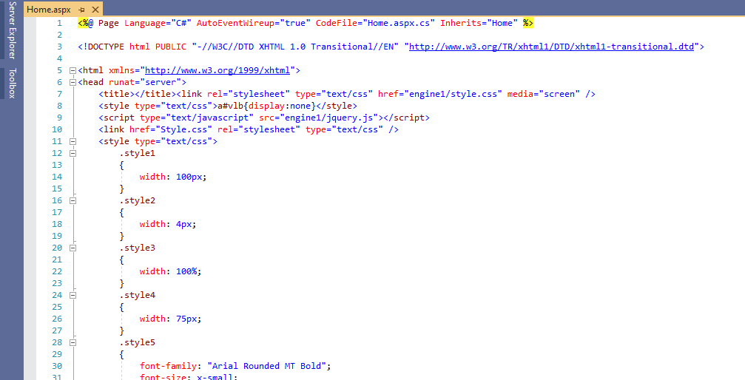

Figure 19: sample codes